Software Requirements Specification
For
Rental Property Management System

Prepared by: Group 12
Date: May/2026

Table of Contents
Table of Contents 1
Revision History 2
1. Introduction 3
1.1. Purpose 3
1.2. Document Conventions 3
1.3. Project Scope and Product Features 3
1.4. References 3
2. Overall Description 4
2.1 Product Perspective 4
2.2 User Classes and Characteristics 4
2.3 Operating Environment 4
2.4 Design and Implementation Constraints 4
2.5 Assumptions and Dependencies 5
3. System Features (Detailed Use Cases) 5
3.1. UC-01: Manage Tenant List 5
3.2. UC-02: Create Rental Invoice 6
3.3 UC-03: Make Payment 6
3.4. UC-04: Submit Maintenance Request 7
3.5 UC-05: Auto Calculate Utility Costs 8
3.6 UC-08: Lease Contract Management 8
4. Data Requirements 9
4.1 Logical Data Model 9
4.2 Data Dictionary 10
4.3 Reports 11
4.4 Data Integrity, Retention, and Disposal 11
5. External Interface Requirements 12
5.1 User Interfaces 12
5.2 Software Interfaces (Detailed API Contracts) 12
5.3 Hardware Interfaces 12
5.4 Communications Interfaces 13
6. Quality Attributes (Quantifiable Metrics) 13
7. System Verification & Testing 13
8. Appendix: Analysis Models 14
8.1 Comprehensive System Use Case Model 15
8.2 Sequence Design Models 15
8.3 Operational Activity Flows 16

Revision History
Name | Date | Reason For Changes | Version
Team 12 | 30/03/2026 | Initial Draft - Extracted operational boundaries and user roles. | 1.0 draft 1
Team 12 | 27/05/2026 | Final Baseline - Integrated detailed API payloads, non-functional quality metrics, and automated test coverage validation. | 1.0 approved

Introduction

1.1. Purpose
This Software Requirements Specification (SRS) document provides a rigorous, exhaustive definition of the functional, data, external interface, and quality requirements for the Rental Property Management System (RPMS). Designed to map baseline legal, financial, and procedural rules directly into software features, this document establishes the authoritative technical baseline for both the React frontend single-page application and the server-side Node.js environment.

1.2. Document Conventions
This text strictly follows the standard IEEE 830 structure. Every requirement description is mapped directly to core constraints. Business Rules are tagged using the prefix [BR-XYZ-NN], where XYZ indicates the domain focus (e.g., USR for User, MTR for Meter, INV for Invoice, PAY for Payment, MNT for Maintenance, CON for Contract, RM for Room, AUD for Audit) and NN represents the incremental digital key. Use Cases are systematically cataloged as UC-XX.

1.3. Project Scope and Product Features
The RPMS is an automated multi-portal ecosystem engineered to digitize boarding house management lifecycles. It eliminates tracking inefficiencies by connecting owners, local facility managers, repair personnel, and tenants through unified web portals. Core product features comprise automated index calculation, secure digital contract binding, responsive online invoice checkouts via simulated webhooks, and image-supported maintenance request tracking.
- Frontend Layer: Component-driven React architecture compiled via Vite, utilizing Tailwind CSS grids for fully adaptive cross-platform rendering.
- Backend Layer: Node.js server powered by Express, deploying secure RESTful routing structures, JWT token session management, and relational persistence via SQLite.

1.4. References
1. IEEE Std 830-1998, IEEE Recommended Practice for Software Requirements Specifications.
2. RPMS Authoritative Operational Business Rules Matrix, Version 1.0.
3. RPMS Test Case Suite and Quality Verification Report, Team 12.

2. Overall Description

2.1 Product Perspective
The RPMS operates as an autonomous, self-contained multi-portal software environment. The architecture utilizes a headless structural split where client-side view components exchange relational data payloads with backend services via secure asynchronous JSON transactions. Data integrity is strictly managed at the persistence layer using SQLite relational constraint engines.

2.2 User Classes and Characteristics
The system enforces role boundaries across exactly four operational user classes:
- Owner (Landlord): Possesses maximum administrative authorization. Oversees high-level property configurations, views long-term financial charts, manages personnel records, and exports legal residency sheets.
- Manager: Handles standard daily facility tasks. Records utility indices, reviews pending resident accounts, and creates contract templates.
- Tenant: Interacts through a personalized portal. Tracks active lease milestones, reviews monthly statements, triggers payment modules, and uploads room repair requests.
- Technical Staff: Field maintenance crew. Reviews assigned repair tickets and updates repair progress flags directly via mobile-friendly views.

2.3 Operating Environment
- Client-Side: Accessible via any modern web browser supporting ECMAScript 6+ (Chrome, Safari, Firefox, Edge) with layouts optimized via Tailwind responsive query frameworks.
- Server-Side: Node.js runtime (LTS version 18 or higher) deployed across virtual Linux application containers or scalable cloud instances.

2.4 Design and Implementation Constraints
- Structural Integrity: Database mutations must enforce relational foreign key connections using PRAGMA foreign_keys = ON within SQLite connections.
- Security Compliance: Cleartext storage of user credentials is strictly prohibited; passwords must be processed through Bcrypt salting and hashing middleware.
- Memory Allocation: To control server-side storage and prevent database bloat, image uploads associated with maintenance tickets are programmatically capped at 5MB per transaction.

2.5 Assumptions and Dependencies
It is assumed that tenant devices maintain reliable network connections. Mock payment processing routines depend on deterministic API behaviors and steady webhook loops without external downtime.

3. System Features (Detailed Use Cases)
This section outlines functional specifications for the system's core capabilities, mapped precisely against authorized business rule matrices.

3.1. UC-01: Manage Tenant List
ID and Name: | UC-01 Manage Tenant List
Primary Actor: | Landlord, Manager
Description: | Enables property administrators to query, filter, append, or modify resident profiles and approve pending web registrations.
Normal Flow: | 1. Administrative actor opens the Tenant Directory sub-view.  2. System calls database layers and displays a paginated list of accounts.  3. Actor clicks on a registration record marked as 'pending'.  4. Actor reviews identity details and clicks 'Approve Account'.  5. System updates database state flags to active and updates the interface.
Alternative Flows: | 1.4 Approve Registration Request: If a tenant registers via the public route, status stays pending until explicitly approved.  1.3 Remove Tenant: Actor deactivates an account, setting status to inactive.
Exceptions: | 1.1.E1 Missing Fields: If mandatory parameters (fullName, email, citizenID, phoneNumber) are missing, the UI raises data-entry alerts and stops database submission.
Business Rules: | BR-USR-02 (Pending login locking), BR-USR-03 (Deactivated account rejection), BR-USR-08 (Mandatory data inputs), BR-AUD-01 (Mandatory mutation logging).

3.2. UC-02: Create Rental Invoice
ID and Name: | UC-02 Create Rental Invoice
Primary Actor: | Landlord, Manager
Description: | Compiles monthly statements by parsing input utility indices and combining them with room rental base prices.
Normal Flow: | 1. Actor selects an occupied room row from the management interface.  2. Actor inputs current electricity and water meter readouts.  3. System extracts the preceding month's metrics and validates data consistency.  4. System computes consumption deltas and multiplies by configured tariff rates.  5. System inserts a new invoice record marked as 'unpaid' and builds a downloadable PDF asset.
Alternative Flows: | None.
Exceptions: | 2.1.E1 Index Inversion Error: If the inputted current metric is lower than historical benchmarks, the system blocks the update, raises an error notification, and prompts for correction.
Business Rules: | BR-MTR-01 & BR-MTR-02 (Continuous index growth rule), BR-MTR-03 (Historical reading continuity), BR-INV-01 (Cost calculation formulas), BR-INV-06 (Default unpaid assignment), BR-INV-12 (PDF compilation requirement).

3.3 UC-03: Make Payment
ID and Name: | UC-03 Make Payment
Primary Actor: | Tenant
Description: | Allows residents to view outstanding balances and clear them using a simulated online checkout interface.
Normal Flow: | 1. Tenant accesses the resident portal dashboard and navigates to the Invoices panel.  2. System fetches unpaid records linked specifically to the user's Tenant ID.  3. Tenant selects an invoice card and clicks 'Pay Online'.  4. Frontend triggers checkout code and renders a dynamic checkout QR code template.  5. Upon transaction resolution, the backend captures an incoming validation webhook.  6. System switches the invoice status flag to 'paid' and updates the dashboard view.
Alternative Flows: | 3.1 Partial Payments: Tenant completes a partial payment slice, leaving the invoice flag in a 'partially_paid' state.
Exceptions: | 3.1.E1 Webhook Communication Timeout: If the payment simulation gate disconnects, the invoice state stays unpaid and an alert displays.
Business Rules: | BR-PAY-01 (Authorized channel list), BR-PAY-03 (Double payment lockout), BR-PAY-04 (Webhook resolution dependencies), BR-INV-11 (Partial compilation logic integration).

3.4. UC-04: Submit Maintenance Request
ID and Name: | UC-04 Submit Maintenance Request
Primary Actor: | Tenant
Description: | Enables residents to file physical room failure reports, requiring a text explanation and an attached photo asset.
Normal Flow: | 1. Tenant enters the Maintenance ticket panel and selects 'New Request'.  2. Tenant enters descriptive details regarding the asset failure.  3. Tenant attaches a picture asset captured from their device.  4. Client application scans file properties to verify it stays within file bounds.  5. Tenant submits the form; backend records the ticket as 'pending' and notifies management.
Alternative Flows: | 4.2 Emergency Escalation: If the description contains critical safety terms (e.g., 'gas leak', 'fire', 'explosion', 'short circuit'), the system bypasses default triage and forces a 'High' priority ranking.
Exceptions: | 4.1.E2 Payload Boundary Error: If file block metrics cross the 5MB ceiling, the UI rejects the file, wipes attachment state, and warns: 'File size must be less than 5MB'.
Business Rules: | BR-MNT-01 (Text explanation requirement), BR-MNT-02 (Keyword prioritization rules), BR-MNT-03 (High-priority alert dispatching), BR-MNT-05 (Tenant deletion authorization restrictions).

3.5 UC-05: Auto Calculate Utility Costs
ID and Name: | UC-05 Auto Calculate Utility Costs
Primary Actor: | System Scheduler
Description: | Automated background process that calculates raw resource consumption deltas and applies tiered pricing structures.
Normal Flow: | Background loop updates utility costs based on data inputs.
Alternative Flows: | None.
Exceptions: | None.
Business Rules: | BR-MTR-04 & BR-MTR-05 (Delta computation definitions), BR-MTR-06 (Numeric constraints), BR-INV-10 (Pre-configured rate matching).

3.6 UC-08: Lease Contract Management

ID and Name: | UC-08 Lease Contract & Transfer Management
Primary Actor: | Landlord, Tenant
Description: | Manages the lease document lifecycle, room reassignments, and final check-out procedures.
Normal Flow: | 1. Landlord inputs room allocation, tenant data, baseline security deposits, and operational duration.  2. System validates room status property is flag-set to 'available'.  3. System commits record in 'draft' state and sends a notification request to the tenant.  4. Tenant reviews terms and submits signature confirmation.  5. Contract enters 'active' status; target room status automatically flips to 'occupied'.
Alternative Flows: | 8.2 Room Transfer Request: Tenant shifts rooms, triggering automated terminal billing and security deposit transfers.
Exceptions: | 8.1.E1 Double Lease Detection: System blocks drafting if the tenant has an existing 'active' lease.
Business Rules: | BR-CON-01 (Single active lease cap per user), BR-RM-04 & BR-RM-05 (Automated room state modification hooks).

4. Data Requirements

4.1 Logical Data Model
The RPMS database uses a clean relational structure to maintain strong data integrity across all features. The core schema centers on six primary entities: Users, Rooms, Contracts, Invoices, MeterReadings, and MaintenanceRequests.
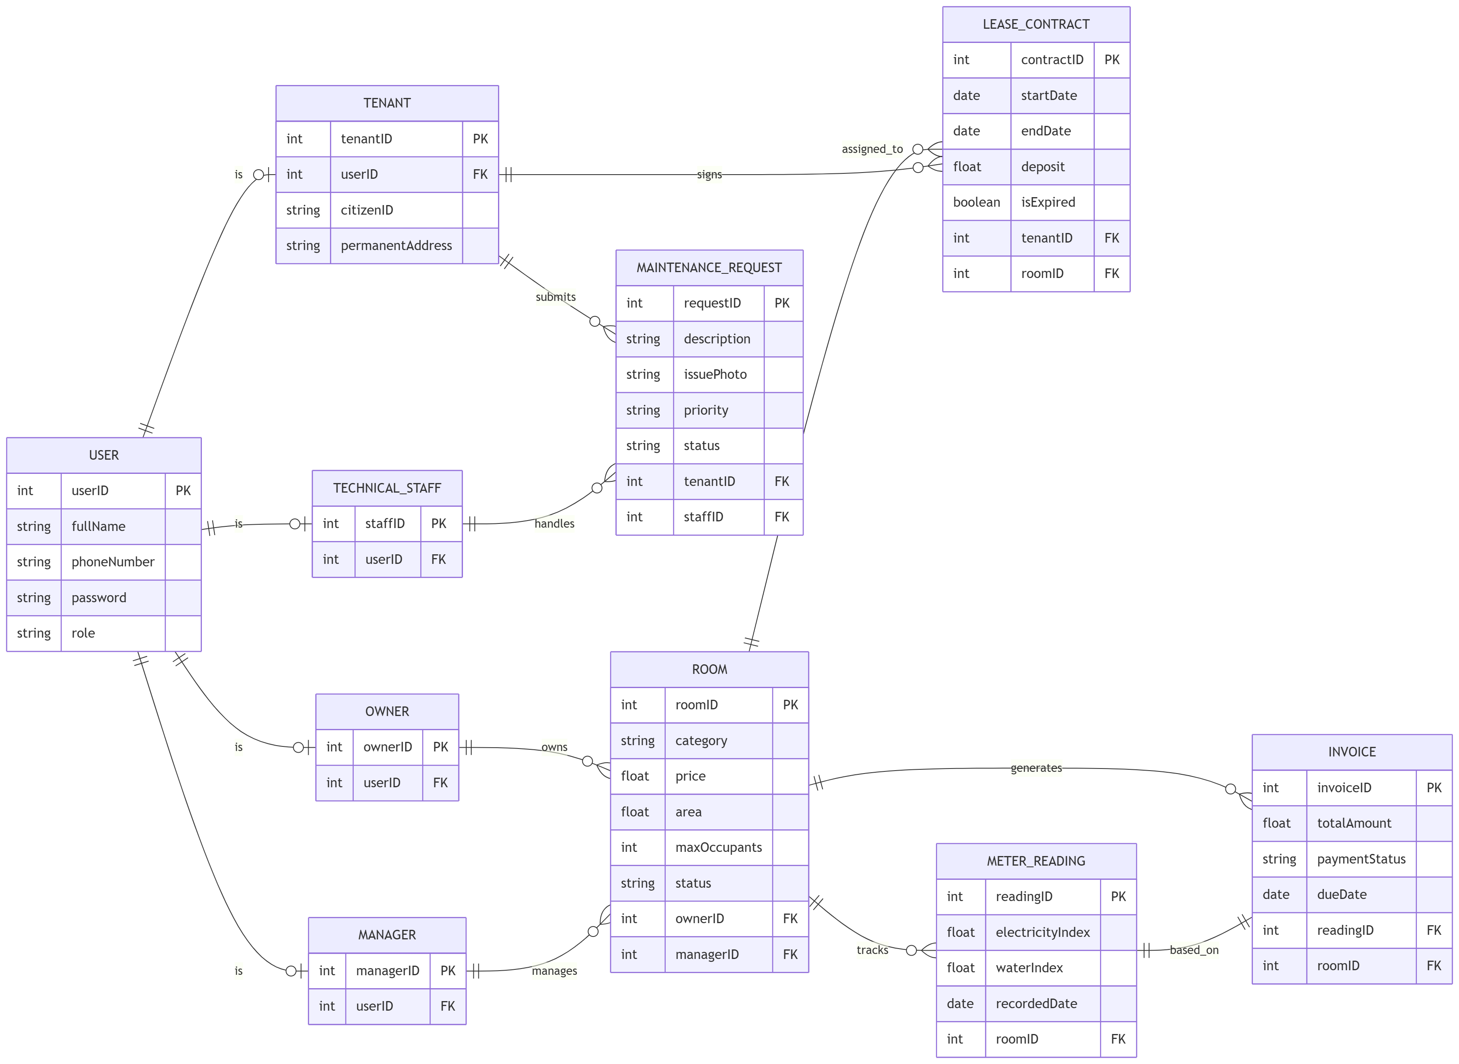

4.2 Data Dictionary
Table 4.2.1: Users Schema Attributes
Attribute Name | Data Type | Constraints | Description
id | INTEGER | PRIMARY KEY, AUTOINCREMENT | Unique internal database identification key.
email | VARCHAR(255) | UNIQUE, NOT NULL | User login credentials identity string.
password_hash | VARCHAR(255) | NOT NULL | Bcrypt security-hashed credential payload.
role | VARCHAR(50) | NOT NULL | System access values: Owner, Manager, Tenant, Technical Staff.
Table 4.2.2: Invoices Schema Attributes
Attribute Name | Data Type | Constraints | Description
id | INTEGER | PRIMARY KEY, AUTOINCREMENT | Unique reference index for financial bills.
tenant_id | INTEGER | FOREIGN KEY REFERENCES Users(id) | Binds invoice record data to a tenant account.
total_amount | DECIMAL(10,2) | NOT NULL, >= 0 | Final calculated financial sum balance.
status | VARCHAR(30) | DEFAULT 'unpaid' | Current lifecycle state: unpaid, paid, partially_paid.

4.3 Reports
The system compiles dynamic inputs to export two standardized analytical report assets: Financial Reports (aggregating revenue streams, payment completion ratios, and outstanding debts) and Legal Forms (formatted tenant registration logs for housing authority declarations).

4.4 Data Integrity, Retention, and Disposal
Data updates execute within single atomic transactions with cascade deletions enabled. To support traceability, database mutations are processed through the auditMutations middleware to log changes instantly.

5. External Interface Requirements

5.1 User Interfaces
The web portal layout adapts dynamically across mobile and desktop viewports using Tailwind layouts. It features interactive utility components, clear payment dashboards with QR checkout triggers, and clean support ticket panels.

5.2 Software Interfaces (Detailed API Contracts)
Relational data exchange between UI portals and backend servers runs over JSON RESTful endpoint configurations, secured using JWT authorization tokens in HTTP request headers.
Endpoint Contract: POST /api/maintenance
Handles incoming facility repair requests and attachment streams.
Request Payload (Multipart/Form-Data) | Response Payload (JSON - 201 Created)
room_id: 104  description: "Ceiling pipe leak"  attachment: [Binary Image Blob] | {  "id": 89,  "status": "pending",  "priority": "Normal",  "created_at": "2026-05-24T02:00:00Z"  }
Endpoint Contract: POST /api/payments/webhook
Processes asynchronous verification data from the simulated payment gateway.
Webhook Body (JSON Payload) | Response Body (JSON - 200 OK)
{  "transaction_id": "TXN-9018247",  "invoice_id": 412,  "amount_paid": 3500000.00,  "status": "SUCCESS"  } | {  "received": true,  "invoice_updated": 412,  "new_state": "paid"  }

5.3 Hardware Interfaces
The cloud-hosted software application operates without specialized or proprietary local physical hardware dependencies.

5.4 Communications Interfaces
All network communications use secure HTTPS encryption over TLS v1.2 or higher. Payment verification features rely on standard webhook endpoints.

6. Quality Attributes (Quantifiable Metrics)
- 6.1 Usability (USA-1): UI templates must adjust gracefully to mobile viewports without text clipping. Client-side validation must catch incomplete fields before sending server requests.
- 6.2 Performance (PER-1): Standard API query endpoints must resolve and return JSON payloads within 1.5 seconds under normal loads. Heavy report processing tasks run asynchronously.
- 6.3 Security (SEC-1): Passwords must be encrypted using Bcrypt with a salt work factor of at least 10 rounds. Restricted routes require verification via role-checking middleware.
- 6.4 Safety (SAF-1): The system must securely store emergency contacts for all occupants, keeping them easily accessible for landlords during facilities incidents.
- 6.5 Availability (AVL-1): Core web portal pathways must maintain 99.5% operational uptime, ensuring tenants can log emergency issues or pay bills at any time.
- 6.6 Robustness (ROB-1): Database connections must use robust connection pooling. Network dropouts during form submission must fail gracefully, roll back state modifications, and display clear error messages.

7. System Verification & Testing
To ensure high reliability, backend business services undergo continuous verification through an automated integration test runner. The test suite uses Jest as the core runner alongside Supertest for mock HTTP transactions, executing against an isolated, process-specific temporary SQLite instance.
The testing pipeline runs 49 automated integration test suites, achieving a 100% success rate. The validation coverage breaks down into four main areas:

Testing Domain Focus | Test Case ID Scope | Target Functional Verification Rule
User Auth & Session Security | TC-AUTH-01 to TC-AUTH-14 | Verifies JWT token issuance, token refresh cycles, and route access restriction rules.
Room Configuration Management | TC-ROOM-01 to TC-ROOM-10 | Verifies data validation bounds, status transitions, and cascading deletion integrity.
Billing & Utility Calculations | TC-INV-01 to TC-INV-15 | Validates utility meter delta calculation, tariff pricing mapping, and input verification.
System Audit Logging Traces | TC-AUDIT-01 to TC-AUDIT-10 | Confirms state mutations automatically write immutable entries into the logging tables.
Test verification runs through an automated coverage script (npm run test: coverage), establishing code reliability before production version bundling.

8. Appendix: Analysis Models
This section serves as the system diagram repository.

8.1 Comprehensive System Use Case Model
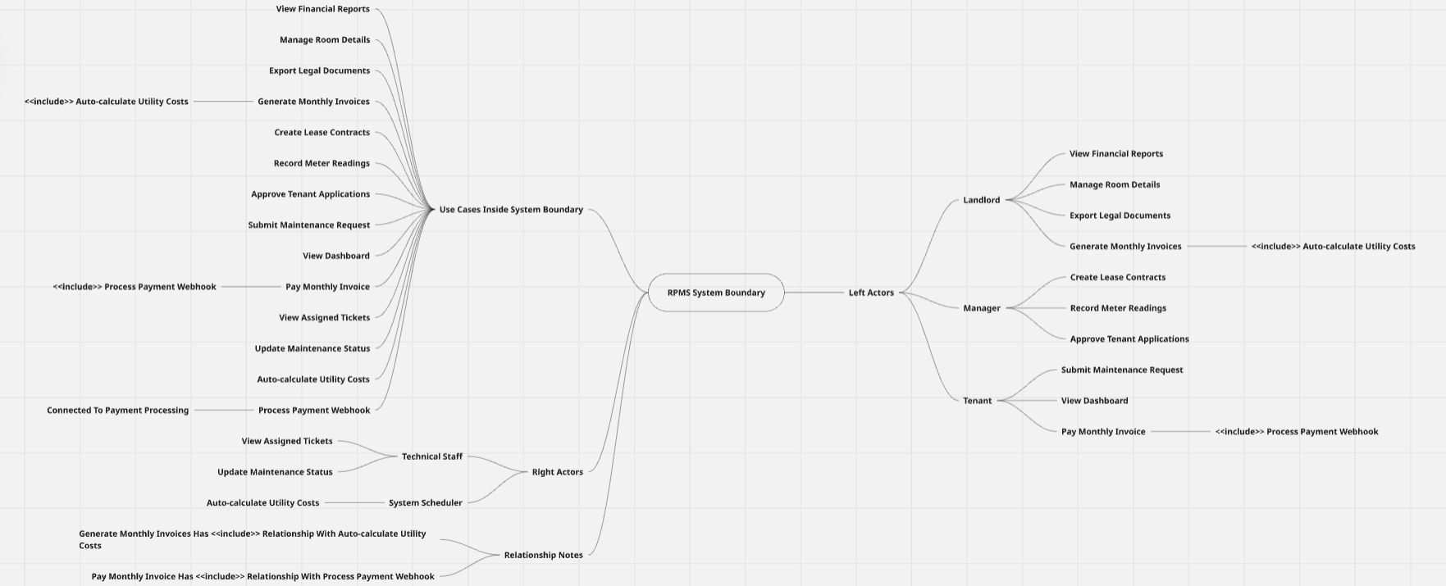
System Use Case Model

8.2 Sequence Design Models
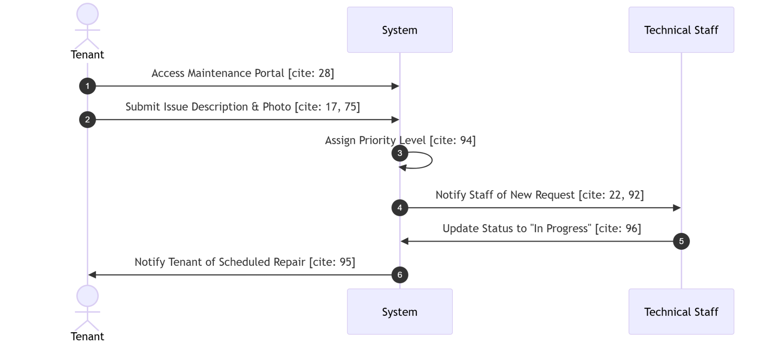
Submitting a Maintenance Request

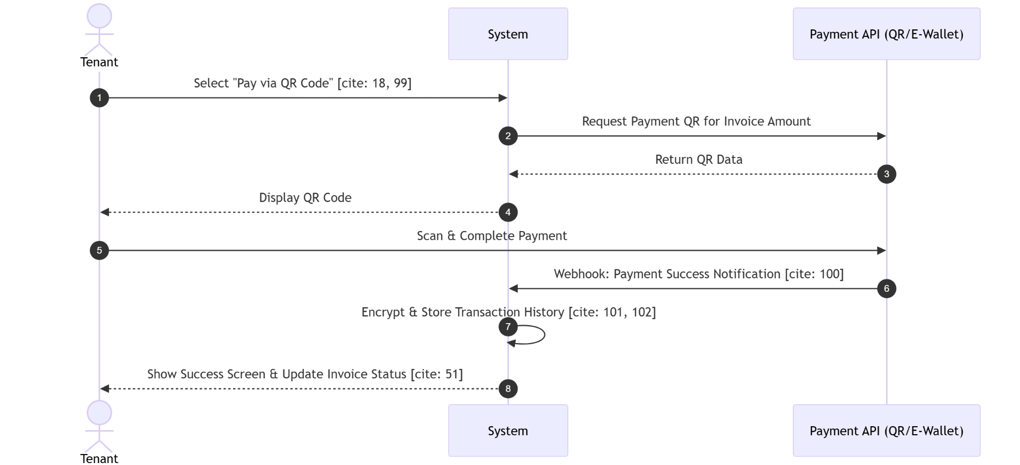
Online Payment Integration

8.3 Operational Activity Flows
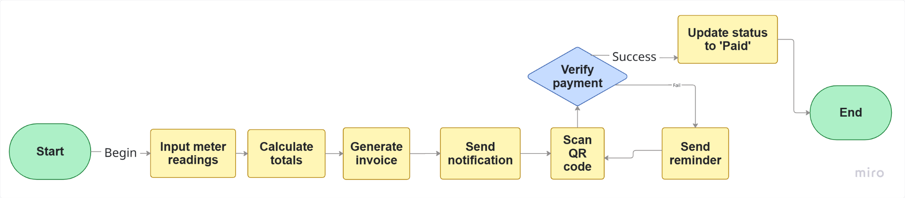
Billing & Invoice Payment Process

